**C++ Introduction**

**C++** is a general-purpose programming language that was developed as an enhancement of the C language to include an object-oriented paradigm. It is an imperative and **compiled** language.

C++ is a middle-level language rendering it the advantage of programming low-level (drivers, kernels) and even higher-level applications (games, GUI, desktop apps, etc.). The basic syntax and code structure of both C and C++ are the same.

So, let's first understand the difference between a high-level and a low-level programming language:

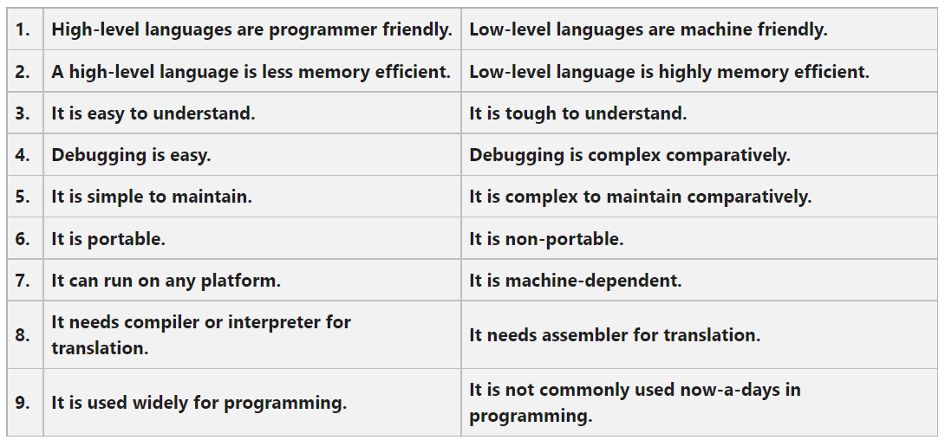Difference between high-level and low-level programming languages

Some of the ***features & key points*** to note about the programming language are as follows:

* Simple
* Machine Independent but Platform Dependent
* Mid-level language
* Rich library support
* Speed of execution
* Pointer and direct Memory-Access
* Object-Oriented
* Compiled Language

**C++ finds varied usage in applications such as:**

* Operating Systems & Systems Programming. e.g. *Linux-based OS (Ubuntu etc.)*
* Browsers *(Chrome & Firefox)*
* Graphics & Game engines *(Photoshop, Blender, Unreal-Engine)*
* Database Engines *(MySQL, MongoDB, Redis etc.)*
* Cloud/Distributed Systems